**The Houston Museum of Natural Science**

Online Curriculum

**Hall of Ancient Egypt**

Knowledge Hunt

3rd – 5th Grade

# **Dear Educator,**

Thank you for downloading the free online curriculum available at HMNS. We are thrilled that you include the world-renowned Houston Museum of Natural Science in your educational toolkit.

Here at HMNS, our mission has always been to provide exemplary educational opportunities for the community. Providing educators like you with a free, fully editable curriculum is just one of many ways we are fulfilling that mission.

Thank you again, and we hope you enjoy your field trip to HMNS!

### How to use this guide:

1. Feel free to edit the questions to suit your student group.
2. The Knowledge Hunt is specifically for the Hall of Ancient Egypt.
3. Visitor services and security staff are posted around the Museum and will be happy to assist you in finding any of the locations or objects mentioned.
4. Please ensure that one chaperone is with every group of ten students at all times as they complete these activities.

For TEKS information or questions, contact us at [**curriculum@hmns.org**](mailto:curriculum@hmns.org%0d%0c)

# **Vocabulary**

ancient, century, civilization, climate, decade, dynasty, floodplain, heritage , hieroglyphic, hieroglyphs, invasion, pharaoh, ruins, sarcophagi, script , tandem

# **Knowledge Hunt**

**Instructions:** Complete the challenges below as you move through the Hall of Ancient Egypt, beginning at the main entrance.

## Entry Room

When you first enter the Hall of Ancient Egypt, you will enter a large room with a timeline of Egyptian history on one wall. Use the text panels and the timeline to help with the questions below.

### Egypt Gift of the Nile

What two natural occurrences helped establish Egyptian civilization over 5000 years ago?

1.

2.

Why do you think the Nile flooding was important for ancient Egyptians?

### Map: Egypt

Label the map with the 12 places listed below, including a compass rose. The text panels throughout the exhibit will help you locate the areas listed.

Lower Egypt Upper Egypt Nile River Red Sea

Mediterranean Sea Alexandria Thebes Memphis

Rome Italy Greece Jerusalem



## The Pillar Room

Move into the next room. This room is dominated by large pillars that form a hallway.

### Pillars

Examine the pillars. What do you notice about the color and design of the pillars? Why do you think the pillars become more worn and faded as they progress down the hall?

What might cause pillars like these to age over the years in structures such as temples?

### Scripts and Writing in Egypt

Find the cases relating to writing, scribes, and hieroglyphs.

Define hieroglyphic –

Define hieratic –

Why did ancient Egyptians start using the hieratic script?

### Fighting and Hunting

On the right wall of the room, there is a display showing men hunting. Describe the scene, including the weapons and materials used to make them.

What does this tell you about ancient Egyptian diet and lifestyle?

### Pharaoh: Lord of the Two Lands

At the far end of the Pillar Room on the right is a text panel labeled "Pharaoh: Lord of the Two Lands."

What was the meaning of the word “Pharaoh”?

What were the king’s responsibilities to his people?

Use the Venn diagram below to compare and contrast the role of a pharaoh in ancient Egypt and the president of the United States.

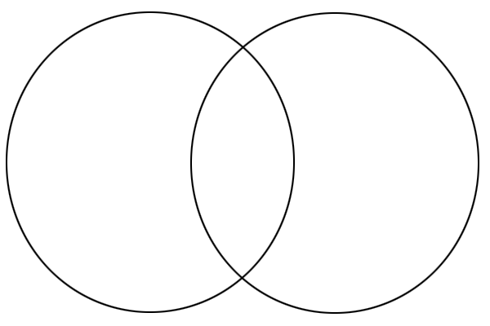

## Temple Hallway

As you leave the Pillar Room, you will enter a long hallway with many nooks, which is modeled after an Egyptian temple.

### Temples

The first alcove on the right contains a text panel labeled "Temples." Read the panel and answer the questions below.

What purpose did temples serve in ancient Egypt?

Describe the relationship of the Pharaoh to the temples and religious life of ancient Egyptians.

### Shabti Figures

Enter the larger room at the end of the hallway. Locate the case of shabti figures. Read the information about the Shabti figures and answer the following questions.

What was the purpose of the shabti figures buried with some ancient Egyptians?

Some Egyptians were buried with “teams” of shabtis. For every ten shabtis, one overseer shabti would keep everyone hard at work in the afterlife.

If a person is buried with 365 shabtis, how many shabti overseers would they need? Show your work.

## Mummy Alcove (Neskhon’s Room)

This room contains three objects: a coffin lid, a full coffin, and a mummy named Neskhons.

Examine the coffin of Neskhons and draw/describe some symbols and shapes you see. Do you recognize any of these symbols from previous displays in this hall?

## Old Kingdom Room

As you move from the mummy to the next room, you will find artifacts from the Old Kingdom Period.

**Food and Drink for the Tomb**

Locate the artifact labeled “case for a food offering.” This case once contained mummified meat meant to provide a meal in the afterlife.

Based on its shape, can you guess what kind of meat the container held?

What food would you pick for your tomb?

## Middle and New Kingdom Rooms

Many of the artifacts here are things that ancient Egyptians would have wanted to bring with them into the afterlife.

Choose one object and explain why you would want to bring that object into the afterlife.

What object from your life would you want to bring into the afterlife and why?

## Coffin Room

Enter the large center room containing several mummies and coffins.

### Mummy of a Man

Find the mummy in the middle of the room.

People came from many different lands to trade and work in ancient Egypt. This mummy has Roman features and shows the diversity of culture in ancient Egypt.

Observe the mummy.

**Coffin and Mummy of Ank-hap**

Locate the “Mummy of Ank-hap" across the room from the “Mummy of a Man.” Observe the mummy and its coffin.

Compare and contrast this mummy with the “Mummy of a Man.” Fill in the chart below.

:

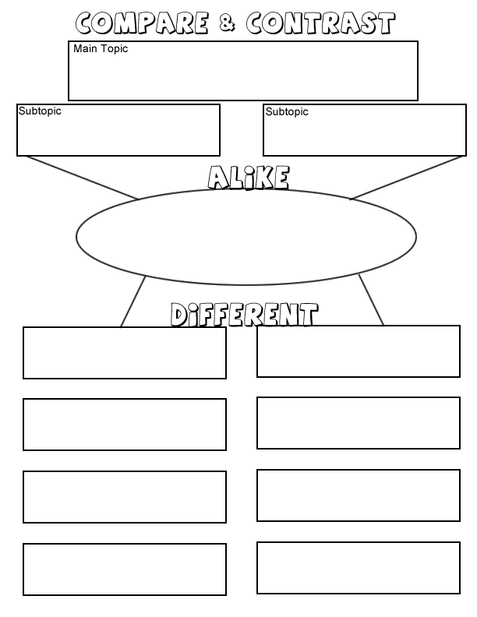

Ank-hap

Roman Mummy

Mummies

## Final Room

### The Rosetta Stone

Why is the Rosetta Stone important?

What are the three different types of writing on the Rosetta Stone?